STL Containers

Contents

1. Containers in C++ STL 2

Reasons to use C++ standard library: 2

What is a container? 2

Types 2

2. Sequence containers 4

std::array 4

std::vector 6

std::deque 9

How std::deque works internally? 10

How deque is able to give good performance for insertion and deletion at both ends? 10

std::forward_list 11

std::list 12

Where are linked lists used? 12

Terminology 13

3. Associative containers 14

std::set and std::multiset 14

std::map and std::multimap 17

4. Unordered associative containers 19

std::unordered_set 19

std::unordered_map 21

std::unordered_multiset 22

std::unordered_multimap 22

5. Container adaptors 23

std::stack 23

What is a Stack? 23

When and where is a stack used? 23

std::queue 25

What is a Queue? 25

When and where is a Queue used? 25

std::priority_queue 26

What is a Priority Queue? 26

6. Time Complexity Table 27

# Containers in C++ STL

## Reasons to use C++ standard library:

1. Code reuse, no need to re-invent the wheel.
2. Efficiency.
3. Accurate, less buggy.
4. Terse, readable code, reduced control flow.
5. standardization, guaranteed availability.
6. A role model of writing library.
7. Good knowledge of data structures and algorithm.

## What is a container?

* A container is a holder object that stores a collection of other objects (its elements). They are implemented as class templates, which allows great flexibility in the types supported as elements.
* The container manages the storage space for its elements and provides member functions to access them, either directly or through iterators (reference objects with similar properties to pointers).

## Types

* STL provides…
  1. Sequence containers.
  2. Associative containers.
  3. Unordered associative containers.
  4. Container adaptors.

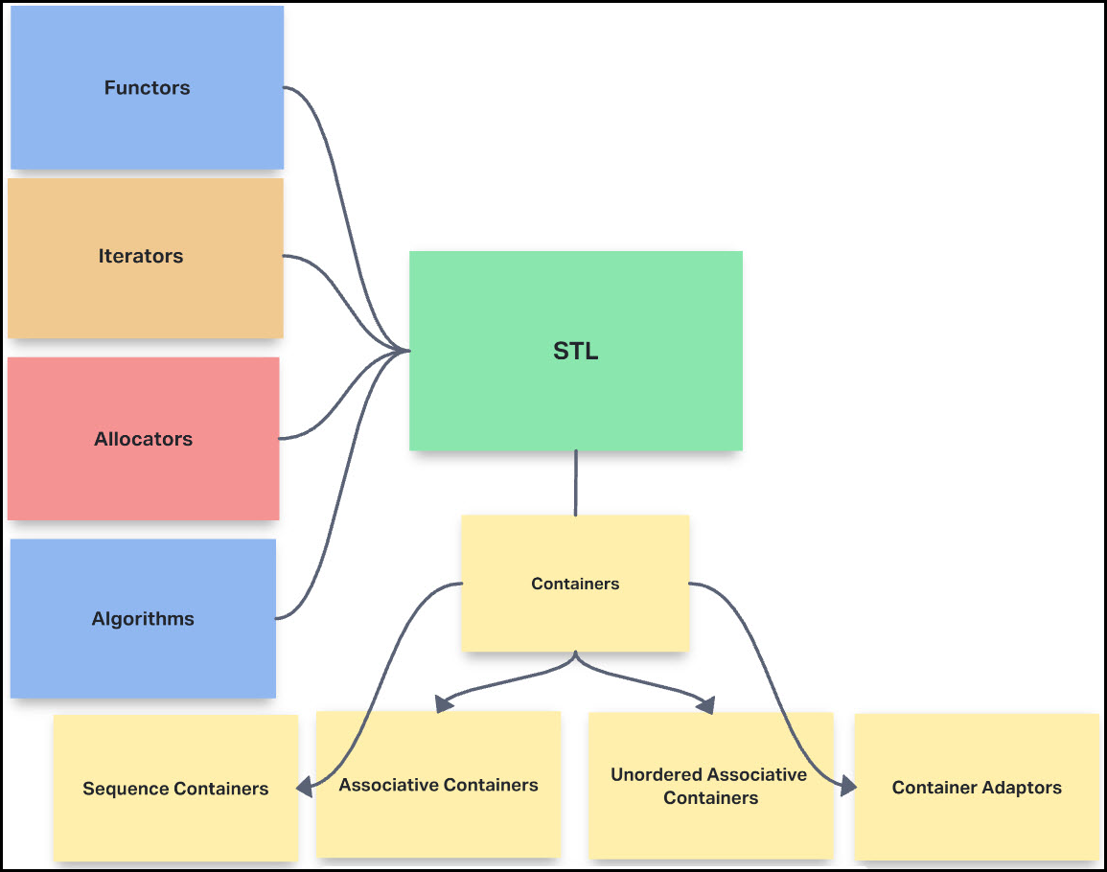

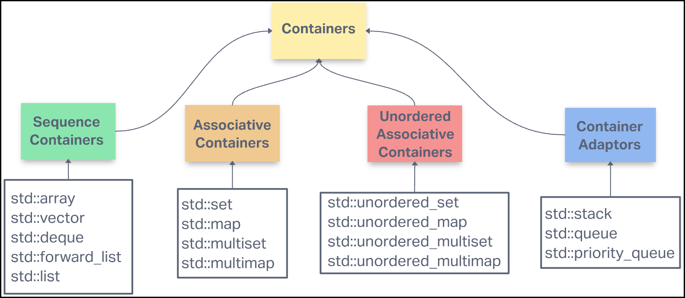

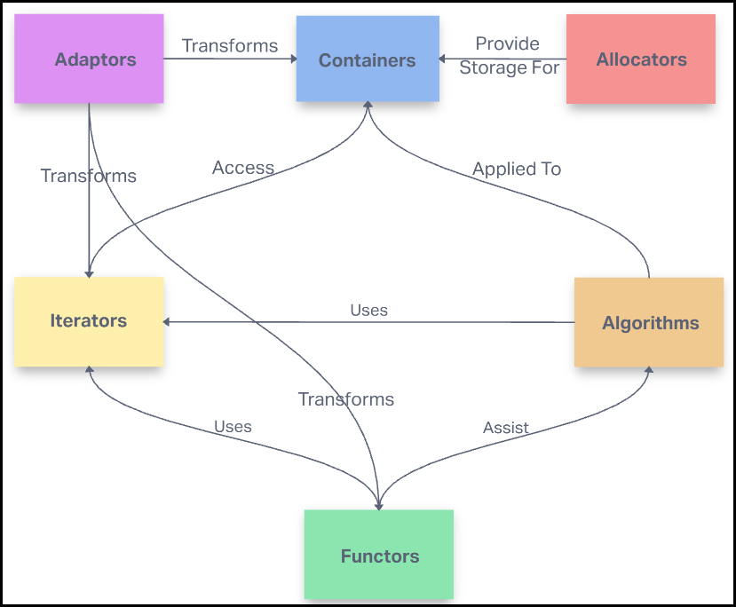

# Sequence containers

* Sequence containers implement data structures that can be accessed sequentially.
* STL provides following sequence containers…
  1. array: Static contiguous array.
  2. vector: Dynamic contiguous array.
  3. deque: Double-ended queue.
  4. forward_list: Singly-linked list.
  5. list: Doubly-linked list.

## std::array

* Arrays are fixed-size sequence containers: they hold a specific number of elements ordered in a strict linear sequence.

|  |  |  |
| --- | --- | --- |
| Element access | | Complexity |
| at | Access specified element with bounds checking | O(1) |
| operator[] | Access specified element | O(1) |
| front | Access the first element | O(1) |
| back | Access the last element | O(1) |
| data | Direct access to the underlying array | O(1) |
| Capacity | |  |
| empty | Checks whether the container is empty | O(1) |
| size | Returns the number of elements | O(1) |
| max_size | Returns the maximum possible number of elements | O(1) |
| Operations | |  |
| fill | Fill the container with specified value | O(n) |
| swap | Swaps the contents | O(n) |

|  |  |
| --- | --- |
| Functionality | Static Array |
| **Access** | **O(1)** |
| **Search** | **O(n)** |
| Insertion | N/A |
| Appending | N/A |
| Deletion | N/A |

|  |
| --- |
| int main(int argc, char* argv[]) {  **// int maxArray[1000000]; of Type 'int, double, char' inside a function.**  **// Max size of 10^7 of type bool array in main().**  **// Globally we can declare 10^7 max size array. 10^8 is max of bool type.**  array<int, 10> myArray; // Garbage!  myArray.*fill*(99); // Fill all the elements with 99!.  myArray.*at*(2) = 0; // Access the 3rd element.  // Iterators  // begin(), end(), rbegin(), rend()  /*  begin end  │ │  ┌──▼──┬─────┬─────┬─────┬─────┬─────┬─────┬ ▼  │ │ │ │ │ │ │ │  ▲ └─────┴─────┴─────┴─────┴─────┴─────┴──▲──┴  │ │  rend rbegin  */  for (auto it = myArray.*begin*(); it != myArray.*end*(); it++) {  *cout* << *it << " ";  }  *cout* << '\n';  for (auto it = myArray.*rbegin*(); it != myArray.*rend*(); it++) {  *cout* << *it << " ";  }  *cout* << '\n';  *cout* << "Size: " << myArray.*size*() << *endl*;  *cout* << "Front: " << myArray.*front*() << " Same as myArray[0]: "  << myArray[0] << *endl*;  *cout* << "Back: " << myArray.*back*() << " Same as myArray[myArray.size()-1]: "  << myArray[myArray.*size*() - 1] << *endl*;  return 0;  } |

## std::vector

* Vectors are same as dynamic arrays with the ability to resize itself automatically when an element is inserted or deleted, with their storage being handled automatically by the container.
* 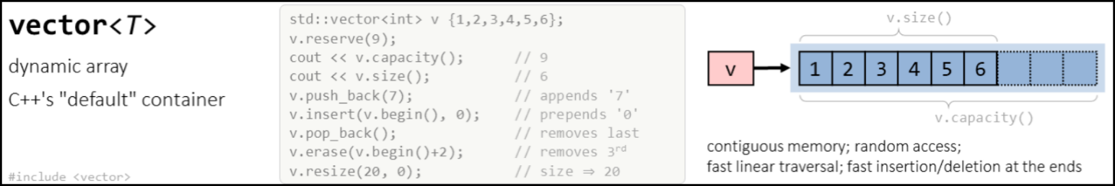Vector elements are placed in contiguous storage so that they can be accessed and traversed using iterators.

|  |  |  |
| --- | --- | --- |
| Vector | | |
| Constructors | | Complexity |
| vector<T> v; | Make an empty vector. | O(1) |
| vector<T> v(n); | Make a vector with N elements. | O(n) |
| vector<T> v(n, value); | Make a vector with N elements, initialized to value. | O(n) |
| vector<T> v(begin, end); | Make a vector and copy the elements from begin to end. | O(n) |
| Accessors | |  |
| **v[i];** | **Return (or set) the I'th element.** | **O(1)** |
| **v.at(i);** | **Return (or set) the I'th element, with bounds checking.** | **O(1)** |
| **v.size();** | **Return current number of elements.** | **O(1)** |
| **v.empty();** | **Return true if vector is empty.** | **O(1)** |
| **v.begin();** | **Return random access iterator to start.** | **O(1)** |
| **v.end();** | **Return random access iterator to end.** | **O(1)** |
| **v.front();** | **Return the first element.** | **O(1)** |
| **v.back();** | **Return the last element.** | **O(1)** |
| **v.capacity();** | **Return maximum number of elements.** | **O(1)** |
| Modifiers | |  |
| **v.push_back(value);** | **Add value to end.** | **O(1) (amortized)** |
| **v.insert(iterator, value);** | **Insert value at the position indexed by iterator.** | **O(n)** |
| **v.pop_back();** | **Remove value from end.** | **O(1)** |
| **v.erase(iterator);** | **Erase value indexed by iterator.** | **O(n)** |
| v.erase(begin, end); | Erase the elements from begin to end. | O(n) |

|  |
| --- |
| int main(int argc, char* argv[]) {  *vector*<int> myVec;  *cout* << "Empty Vector Size: " << myVec.*size*() << *endl*; // Prints 0  myVec.*push_back*(0); // {0}  myVec.*push_back*(2); // {0,2}  *cout* << "After 2 elements, Size: " << myVec.*size*() << *endl*; // Prints 2  myVec.*pop_back*(); // {0}  *cout* << "After Pop, Size: " << myVec.*size*() << *endl*; // Prints 1  myVec.*push_back*(3); // {0,3}  myVec.*push_back*(4); // {0,3,4}  myVec.*push_back*(5); // {0,3,4,5}  myVec.*clear*(); // Erase all the elements and size is 0;  *cout* << "After Clear, Size: " << myVec.*size*() << *endl*; // Prints 0  *vector*<int> vec1(4, 2); // {2,2,2,2}  *vector*<int> vec2(vec1.*begin*(), vec1.*end*()); // -> [)  *vector*<int> vec3(vec2); // Copy construct.    myVec.*push_back*(0); // {0}  myVec.*push_back*(2); // {0,2}  myVec.*push_back*(3); // {0,2,3}  myVec.*push_back*(4); // {0,2,3,4}  myVec.*push_back*(5); // {0,2,3,4,5}  *vector*<int> vec4 (myVec.*begin*(), myVec.*begin*()+3); // vec4 -> {0,2,3}, cos [)  for (auto i : vec4)  *cout* << i << " ";  *cout* << "\n";  myVec.*clear*();  // emplace_back will take less time than push_back  myVec.*emplace_back*(1);  myVec.*emplace_back*(2);  myVec.*emplace_back*(3);  myVec.*emplace_back*(4);  myVec.*emplace_back*(5);  myVec.*emplace_back*(6);  *cout* << "myVec: "; // myVec: 1 2 3 4 5 6  for (auto i : myVec)  *cout* << i << " ";  *cout* << "\n";  *cout* << "vec1: "; // vec1: 2 2 2 2  for (auto i : vec1)  *cout* << i << " ";  *cout* << "\n";  *cout* << "After swap: \n";  myVec.*swap*(vec1);  *cout* << "myVec: "; // myVec: 2 2 2 2  for (auto i : myVec)  *cout* << i << " ";  *cout* << "\n";  *cout* << "vec1: "; // vec1 : 1 2 3 4 5 6  for (auto i : vec1)  *cout* << i << " ";  *cout* << "\n";  // 2D vector  *vector*<*vector*<int>> my2DVec;  my2DVec.*push_back*(myVec);  my2DVec.*push_back*(vec1);  my2DVec.*push_back*(vec2);  my2DVec.*push_back*(vec3);  // Defining 3X4 matrix. 3 Rows, 4 Columns, initialized with -1  *vector*<*vector*<int>> my2DVec1(3, *vector*<int>(4, -1));  for (auto i : my2DVec1) {  for (auto j : i) {  *cout* << j << " ";  }  *cout* << "\n";  }  *vector*<int> arrOfVector[5]; // Array of 5 vector<int>  return 0;  } |

## std::deque

* Double-ended queues are sequence containers with the feature of expansion and contraction on both ends.
* They are like vectors but are more efficient in case of insertion and deletion of elements. Unlike vectors, contiguous storage allocation may not be guaranteed.

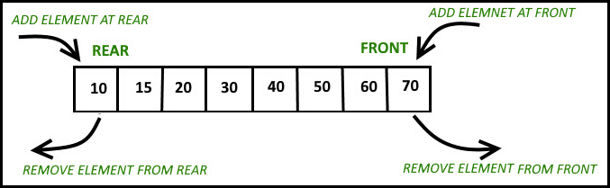

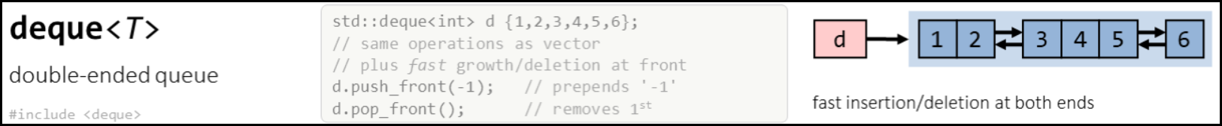

|  |  |  |
| --- | --- | --- |
| Deque | | |
| Constructors | | Complexity |
| deque<T> d; | Make an empty deque. | O(1) |
| deque<T> d(n); | Make a deque with N elements. | O(n) |
| deque<T> d(n, value); | Make a deque with N elements, initialized to value. | O(n) |
| deque<T> d(begin, end); | Make a deque and copy the values. | O(n) |
| Accessors | |  |
| **d[i];** | **Return (or set) the ith element.** | **O(1)** |
| **d.at(i);** | **Return (or set) the ith element, with bounds checking.** | **O(1)** |
| **d.size();** | **Return current number of elements.** | **O(1)** |
| **d.empty();** | **Return true if deque is empty.** | **O(1)** |
| d.begin(); | Return random access iterator to start. | O(1) |
| d.end(); | Return random access iterator to end. | O(1) |
| d.front(); | Return the first element. | O(1) |
| d.back(); | Return the last element. | O(1) |
| Modifiers | |  |
| **d.push_front(value);** | **Add value to front.** | **O(1) (amortized)** |
| **d.push_back(value);** | **Add value to end.** | **O(1) (amortized)** |
| **d.insert(iterator, value);** | **Insert value at the position indexed by iterator.** | **O(n)** |
| **d.pop_front();** | **Remove value from front.** | **O(1)** |
| **d.pop_back();** | **Remove value from end.** | **O(1)** |
| **d.erase(iterator);** | **Erase value indexed by iterator.** | **O(n)** |
| **d.erase(begin, end);** | **Erase the elements from begin to end.** | **O(n)** |

### How std::deque works internally?

### How deque can give good performance for insertion and deletion at both ends?

* 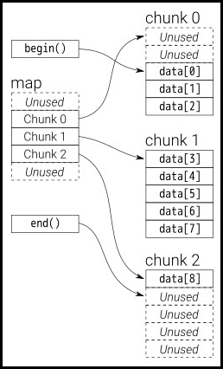A deque is generally implemented as a collection of memory blocks. These memory blocks contain the elements at contiguous locations.
* When we create a deque object it internally allocates a memory block to store the elements at contiguous location.
* When we insert an element at 'end' it stores that in allocated memory block until it gets filled and when this memory block gets filled with elements then it allocates a new memory block and links it with the 'end' of previous memory block. Now further inserted elements in the back are stored in this new memory block.
* When we insert an element in 'front' it allocates a new memory block and links it with the 'front' of previous memory block. Now further inserted elements in the 'front' are stored in this new memory block unless it gets filled.
* Consider deque as a linked list of vectors i.e. each node of this linked list is a memory block that store elements at contiguous memory location and each of the memory block node is linked with its previous and next memory block node.

## std::forward_list

* Forward list implements singly linked list.
* Introduced from C++11, forward list is more useful than other containers in insertion, removal, and moving operations (like sort) and allow time constant insertion and removal of elements.
* It differs from the list by the fact that the forward list keeps track of the location of only the next element while the list keeps track of both the next and previous elements, thus increasing the storage space required to store each element.
* The drawback of a forward list is that it cannot be iterated backward and its individual elements cannot be accessed directly.



|  |  |  |
| --- | --- | --- |
| Forward List | | |
| Constructors | | Complexity |
| forward_list<T> l; | Make an empty forward_list. | O(1) |
| forward_list<T> l(begin, end); | Make a forward_list and copy the values from begin to end. | O(n) |
| Accessors | |  |
| l.size(); | No 'size()' member function. | N/A |
| l.empty(); | Return true if forward_list is empty. | O(1) |
| l.begin(); | Return iterator to beginning. | O(1) |
| l.end(); | Return iterator to end. | O(1) |
| l.front(); | Return the first element. | O(1) |
| Modifiers | |  |
| l.push_front(value); | Add value to front. | O(1) |
| l.insert_after(iterator, value); | Insert value after position indexed by iterator. | O(1) |
| l.pop_front(); | Remove value from front. | O(1) |
| l.pop_back(); | Remove value from end. | O(1) |
| l.erase_after(iterator); | Erase next value after the iterator. | O(1) |
| l.erase_after(begin, end); | Erase the elements from begin to end. | O(1) |
| l.remove(value); | Remove all occurrences of value. | O(n) |
| l.remove_if(test); | Remove all element that satisfy test. | O(n) |
| l.reverse(); | Reverse the forward_list. | O(n) |
| l.sort(); | Sort the forward_list. | O(n log n) |
| l.sort(comparison); | Sort with comparison function. | O(n logn) |
| l.merge(l2); | Merge sorted forward_lists. | O(n) |

## std::list

* std::list is a container that supports constant time insertion and removal of elements from anywhere in the container.
* Fast random access is not supported. It is usually implemented as a doubly linked list.
* Compared to std::forward_list this container provides bidirectional iteration capability while being less space efficient.

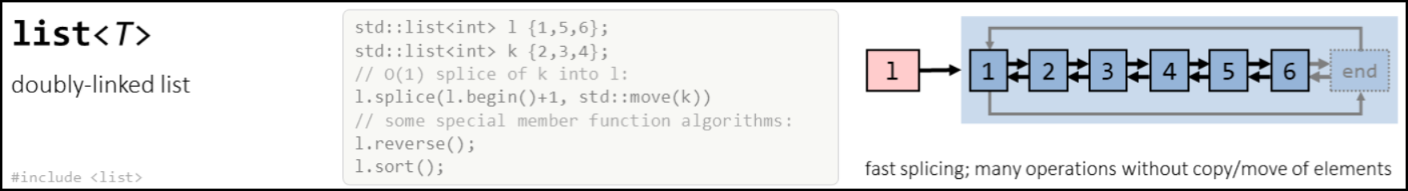

|  |  |  |
| --- | --- | --- |
| List | | |
| Constructors | | Complexity |
| list<T> l; | Make an empty list. | O(1) |
| list<T> l(begin, end); | Make a list and copy the values from begin to end. | O(n) |
| Accessors | |  |
| l.size(); | Return current number of elements. | O(1) |
| l.empty(); | Return true if list is empty. | O(1) |
| l.begin(); | Return bidirectional iterator to start. | O(1) |
| l.end(); | Return bidirectional iterator to end. | O(1) |
| l.front(); | Return the first element. | O(1) |
| l.back(); | Return the last element. | O(1) |
| Modifiers | |  |
| **l.push_front(value);** | **Add value to front.** | **O(1)** |
| **l.push_back(value);** | **Add value to end.** | **O(1)** |
| l.insert(iterator, value); | Insert value after position indexed by iterator. | O(1) |
| l.pop_front(); | Remove value from front. | O(1) |
| l.pop_back(); | Remove value from end. | O(1) |
| l.erase(iterator); | Erase value indexed by iterator. | O(1) |
| l.erase(begin, end); | Erase the elements from begin to end. | O(1) |
| l.remove(value); | Remove all occurrences of value. | O(n) |
| l.remove_if(test); | Remove all element that satisfy test. | O(n) |
| l.reverse(); | Reverse the list. | O(n) |
| l.sort(); | Sort the list. | O(n log n) |
| l.sort(comparison); | Sort with comparison function. | O(n log n) |
| l.merge(l2); | Merge sorted lists. | O(n) |

### Where are linked lists used?

* Used in many List, Queue & Stack implementations.
* Great for creating circular lists.
* Can easily model real world objects such as trains.
* Used in separate chaining, which is present certain Hash table implementations to deal with hashing collisions.
* Often used in the implementation of adjacency lists for graphs.

### Terminology

* Head: The first node in a linked list
* Tail: The last node in a linked list
* Pointer: Reference to another node
* Node: An object containing data and pointer(s)

|  |  |  |
| --- | --- | --- |
| Complexity | | |
|  | Singly LL | Doubly LL |
| **Access** | **O(n)** | **O(n)** |
| **Search** | **O(n)** | **O(n)** |
| Insertion at Head | O(1) | O(1) |
| Insertion at Tail | O(1) | O(1) |
| Remove at Head | O(1) | O(1) |
| Remove at Tail | O(n) | O(1) |
| **Remove in the Middle** | **O(n)** | **O(n)** |

# Associative containers

* Associative containers implement **sorted data structures** that can be quickly searched (O(log n) complexity).
* STL provides following associative containers…
  1. set: Collection of unique keys, sorted by keys.
  2. map: Collection of key-value pairs, sorted by keys, keys are unique.
  3. multiset: Collection of keys, sorted by keys.
  4. multimap: Collection of key-value pairs, sorted by keys.

## std::set and std::multiset

* std::set store objects and automatically keep them sorted and quick to find. In a set, there is only one copy of each object.
* std::multiset are declared and used the same as sets but allow duplicate elements.

|  |  |  |
| --- | --- | --- |
| set & multiset | | |
| Constructors | | Complexity |
| set<type,compare> s; | Make an empty set. compare should be a binary predicate for ordering the set. It's optional and will default to a function that uses operator<. | O(1) |
| set<type,compare> s(begin, end); | Make a set and copy the values from begin to end. | O(n log n) |
| Accessors | |  |
| **s.find(key)** | **Return an iterator pointing to an occurrence of key in s, or s.end() if key is not in s.** | **O(log n)** |
| s.lower_bound(key) | Return an iterator pointing to the first occurrence of an item in s not less than key, or s.end() if no such item is found. | O(log n) |
| s.upper_bound(key) | Return an iterator pointing to the first occurrence of an item greater than key in s, or s.end() if no such item is found. | O(log n) |
| s.equal_range(key) | Returns pair<lower_bound(key), upper_bound(key)>. | O(log n) |
| s.count(key) | Returns the number of items equal to key in s. | O(log n) |
| s.size(); | Return current number of elements. | O(1) |
| s.empty(); | Return true if set is empty. | O(1) |
| s.begin() | Return an iterator pointing to the first element. | O(1) |
| s.end() | Return an iterator pointing one past the last element. | O(1) |
| Modifiers | |  |
| s.insert(iterator, key) | Inserts key into s. iterator is taken as a "hint" but key will go in the correct position no matter what. Returns an iterator pointing to where key went. | O(log n) |
| **s.insert(key)** | **Inserts key into s and returns a pair<iterator, bool>, where iterator is where key went and bool is true if key was actually inserted, i.e., was not already in the set.** | **O(log n)** |

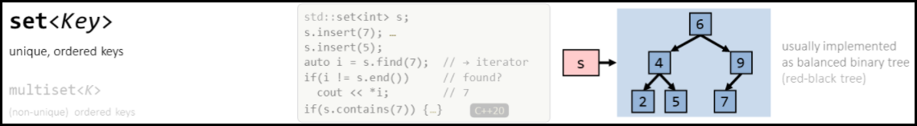

|  |
| --- |
| int main(int argc, char* argv[]) {  // Given n elements, print only unique elements!  *set*<int> s;  *cout* << "Enter number of elements: ";  int n; *cin* >> n; // 6  *cout* << "Enter " << n << " elements: ";  while (n--) {  int ele; *cin* >> ele; // 1 1 2 2 4 4  s.insert(ele); // **Takes O(log n)**  }  // **Elements are unique and are also sorted!**  *cout* << "Unique elements are: "; //1 2 4  for (auto i : s)  *cout* << i << " ";  *cout* << "\n";  // **Set doesn't provide the random access. s[2] is wrong**.  s.*erase*(s.*begin*()); **// {2, 4} takes O(log n)**  s.insert(1); // {1, 2, 4}  s.insert(5); // {1, 2, 4, 5}  auto it = s.*find*(4); // **Takes O(log n)**  s.*erase*(s.*begin*(), it); // **You cannot do s.erase(s.begin(), s.begin()+2)**  *cout* << "Elements are: "; // Elements are : 4 5 -> erases [)  for (auto i : s)  *cout* << i << " ";  *cout* << "\n";  s.*erase*(5); **// Erase the key 5, takes O(log n)**  *cout* << "After deleting 5: "; // After deleting 5: 4  for (auto i : s)  *cout* << i << " ";  *cout* << "\n";  auto it = s.*find*(100); // it -> s.end()  s.*emplace*(9); // **Emplace is faster**.  return 0;  } |

|  |
| --- |
| int main(int argc, char* argv[]) {  *multiset*<int> ms;  ms.insert(1); ms.insert(2); ms.insert(3); // **Takes O(log n)**  ms.*emplace*(1); ms.*emplace*(3); // Same as insert. But faster!  // 'multiset' stores duplicate elements in sorted order.  *cout* << "Elements are: "; // Elements are: 1 1 2 3 3  for (auto i : ms) *cout* << i << " ";  *cout* << "\nErasing all 3's: ";  ms.*erase*(3); // **Takes O(log n)**  *cout* << "\nElements are: "; // Elements are: 1 1 2  for (auto i : ms) *cout* << i << " ";  ms.*emplace*(3); ms.*emplace*(4);  ms.*emplace*(3); ms.*emplace*(5);  *cout* << "\nElements are: "; // Elements are: 1 1 2 3 3 4 5  for (auto i : ms) *cout* << i << " ";  // 'find' returns the iterator pointing to the first element.  auto it = ms.*find*(3); // **Takes O(log n)**  ms.*erase*(it); // **Takes O(log n)**  *cout* << "\nElements are: "; // Elements are: 1 1 2 3 4 5  for (auto i : ms) *cout* << i << " ";    *cout* << "\nElement 1 occurs " << ms.*count*(1) << " times";    return 0;  } |

## std::map and std::multimap

* Maps can be thought of as generalized vectors. They allow map[key] = value for any kind of key, not just integers.
* Maps are implemented with balanced binary search trees, typically red-black trees. Thus, they provide **logarithmic storage and retrieval times**. Because they use search trees, maps need a comparison predicate to sort the keys. operator<() will be used by default if none is specified a construction time.
* Maps store <key, value> pair's. That's what map iterators will return when dereferenced. To get the value pointed to by an iterator, you need to say (*mapIter).second. Usually though you can just use map[key] to get the value directly.

|  |  |  |
| --- | --- | --- |
| map & multimap | | |
| Constructors | | Complexity |
| map<key_type,value_type,key_compare> m; | Make an empty map. key_compare should be a binary predicate for ordering the keys. It's optional and will default to a function that uses operator<. | O(1) |
| map<key_type,value_type,key_compare> m(begin, end); | Make a map and copy the values from begin to end. | O(n log n) |
| Accessors | |  |
| **m[key]** | **Return the value stored for key. This adds a default value if key not in map.** | **O(log n)** |
| **m.find(key)** | **Return an iterator pointing to a key-value pair, or m.end() if key is not in map.** | **O(log n)** |
| m.lower_bound(key) | Return an iterator pointing to the first pair containing key, or m.end() if key is not in map. | O(log n) |
| m.upper_bound(key) | Return an iterator pointing one past the last pair containing key, or m.end() if key is not in map. | O(log n) |
| m.equal_range(key) | Return a pair containing the lower and upper bounds for key. This may be more efficient than calling those functions separately. | O(log n) |
| **m.size();** | **Return current number of elements.** | **O(1)** |
| **m.empty();** | **Return true if map is empty.** | **O(1)** |
| m.begin() | Return an iterator pointing to the first pair. | O(1) |
| m.end() | Return an iterator pointing one past the last pair. | O(1) |
| Modifiers | |  |
| **m[key] = value;** | **Store value under key in map.** | **O(log n)** |
| **m.insert(pair)** | **Inserts the <key, value> pair into the map. Equivalent to the above operation.** | **O(log n)** |

Warning: map[key] creates a dummy entry for key if one wasn't in the map before. Use map.find(key) if you don't want this to happen.

* multimaps are like map except that they allow duplicate keys.
* 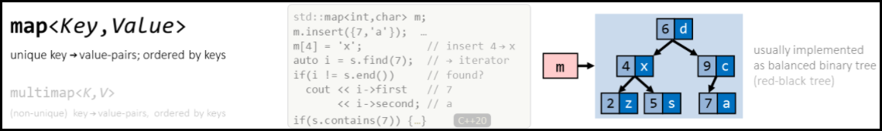**map[key] is not defined for multimaps.** Instead you use lower_bound() and upper_bound(), or equal_range(), to get the iterators for the beginning and end of the range of values stored for the key.

|  |
| --- |
| int main(int argc, char* argv[]) {  *map*<*string*, int> mp;  mp["Nishi"] = 39; // **Takes O(log n)**  mp["Rachhu"] = 35; mp["Gattu"] = 10;  mp["Rajanna"] = 70; mp["Prabha"] = 65;  mp["Rachhu"] = 36; // Overwrites previous value.    for (auto i : mp) // **Returns a pair!!!**  *cout* << "Name: " << i.*first* << " Age: " << i.*second* << *endl*;  /* Map stores unique elements sorted order based on key.  Name: Gattu Age: 10  Name: Nishi Age: 39  Name: Prabha Age: 65  Name: Rachhu Age: 36  Name: Rajanna Age: 70  */  mp.*emplace*("Dummy", 99); // **Takes O(log n)**, "Dummy" will be on top! (**Sorted**)  mp.*erase*(mp.*begin*()); // "Dummy" will be erased. Takes **O(log n)**  mp["Apple"] = 10;  mp.*erase*("Apple"); // **Takes O(log n)**  auto it = mp.*find*("Rajanna"); // **Takes O(log n)**  if (it != mp.*end*())  *cout* << "Found " << it->*first* << *endl*;  if (!mp.*empty*()) *cout* << "Map is not empty!\n";  mp.*clear*(); // Clears map.  return 0;  } |

# Unordered associative containers

* Unordered associative containers implement **unsorted** (**hashed**) data structures that can be **quickly searched (**O(1) **amortized,** O(n) **worst-case complexity)**.
* STL provides following unordered associative containers…
  1. unordered_set: Collection of unique keys, hashed by keys.
  2. unordered_map: Collection of key-value pairs, hashed by keys, keys are unique.
  3. unordered_multiset: Collection of keys, hashed by keys.
  4. unordered_multimap: Collection of key-value pairs, hashed by keys.

## std::unordered_set

* An unordered_set is implemented using a hash table where keys are **hashed** into indices of a hash table so that the insertion is always **randomized**.
* All operations on the unordered_set takes constant time O(1) on an average which can go up to linear time O(n) in worst case which depends on the internally used hash function.

|  |  |  |
| --- | --- | --- |
| unordered_set | | |
| Constructors | | Complexity |
| unordered_set<type,compare> s; | Make an empty set. compare should be a binary predicate for ordering the set. It's optional and will default to a function that uses operator<. | O(1) |
| unordered_set<type,compare> s(begin, end); | Make a set and copy the values from begin to end. | O(n) |
| Accessors | |  |
| s.find(key) | Finds element with specific key | O(1) |
| s.count(key) | Returns the number of elements with key that compares equal to the specified argument key, which is either 1 or 0 since this container does not allow duplicates. | O(1) |
| s.contains(key) | Checks if the container contains element with specific key | O(1) |
| s.size(); | Return current number of elements. | O(1) |
| s.empty(); | Return true if set is empty. | O(1) |
| s.begin() | Return an iterator pointing to the first element. | O(1) |
| s.end() | Return an iterator pointing one past the last element. | O(1) |
| Modifiers | |  |
| s.insert(iterator, key) | Inserts value. | O(1) (amortized) |
| s.erase(it); | Removes specified elements from the container. | O(1) (amortized) |
| s.emplace(key) | Insert an element in an unordered_set container. | O(1) (amortized) |

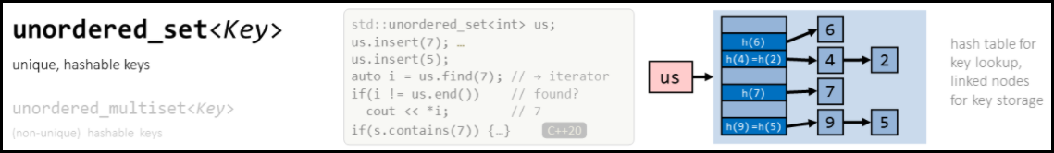

|  |
| --- |
| int main(int argc, char* argv[]) {  *unordered_set*<int> s;  s.insert(4); **// Takes O(1)**  s.insert(2);  s.insert(4);  s.insert(1);  // Stores **unique** elements but **order is not guaranteed**.  // Whereas **'set'** stores the elements in **ascending order by default**.  *cout* << "Unique elements are: "; // 4 2 1  for (auto i : s)  *cout* << i << " ";  *cout* << "\n";  // All other operations such as 'find', 'erase' takes O(1)  s.*erase*(s.*begin*()); **// Takes O(1)**  auto it = s.*find*(1);**// Takes O(1)**  if (it != s.*end*())  *cout* << "1 is present in the set!\n";  s.*emplace*(3); **// Takes O(1)**  *cout* << "Size: " << s.*size*() << *endl*; **// Takes O(1)**  if (!s.*empty*()) **// Takes O(1)**  *cout* << "Set is not empty!\n";    return 0;  } |

## std::unordered_map

* Unordered maps are associative containers that store elements formed by the combination of a key value and a mapped value, and which allows for fast retrieval of individual elements based on their keys.
* The elements in the unordered_map **are not sorted** in any particular order with respect to either their key or mapped values, but organized into **buckets** depending on their hash values to allow for fast access to individual elements directly by their key values.
* The unordered_map<int, int> M is the implementation of Hash Table which makes the complexity of operations like insert, delete and search to amortized O(1).

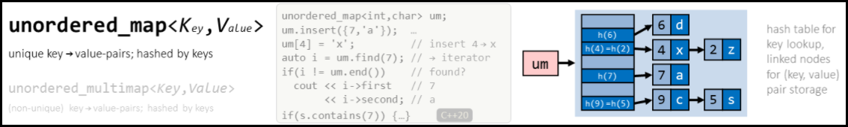

|  |
| --- |
| int main(int argc, char* argv[]) {  *unordered_map*<*string*, int> ump;  ump["Nishi"] = 39; // **Takes O(1)**  ump["Rachhu"] = 35; ump["Gattu"] = 10;  ump["Rajanna"] = 70; ump["Prabha"] = 65;  ump["Rachhu"] = 36; // Overwrites previous value.    for (auto i : ump) // Returns a pair!!!  *cout* << "Name: " << i.*first* << " Age: " << i.*second* << *endl*;  /* Map stores unique elements sorted order based on key.  Name: Nishi Age: 39  Name: Rajanna Age: 70  Name: Gattu Age: 10  Name: Rachhu Age: 36  Name: Prabha Age: 65  */  ump.*emplace*("Dummy", 99); // **Takes O(1)**  ump.*erase*(ump.*begin*()); // **Takes O(1), Don’t know which one is erased!**  ump["Apple"] = 10;  ump.*erase*("Apple"); // **Takes O(1)**  auto it = ump.*find*("Rajanna"); // **Takes O(1)**  if (it != ump.*end*())  *cout* << "Found " << it->*first* << *endl*;  if (!ump.*empty*()) *cout* << "Map is not empty!\n";  ump.*clear*(); // Clears map.  return 0;  } |

## std::unordered_multiset

* Similar to unordered_set, but allows duplicate elements.
* The internal implementation of unordered_multiset is same as that of unordered_set and also uses hash table for searching, just the count value is associated with each value in former one.
* All operation on unordered_multiset takes constant time O(1) on average but can go up to linear in worst case.

## std::unordered_multimap

* Similar to unordered_map, but allows duplicate elements.
* The internal implementation of unordered_multimap is the same as that of unordered_map but for duplicate keys, another count value is maintained with each key-value pair.
* All operation on unordered_multimap takes a constant amount of time O(1) on an average but time can go to linear in the worst case depending on internally used hash function.

## 

# Container adaptors

* Container adaptors provide a different interface for sequential containers.
* STL provides following container adaptors…
  1. stack: Adapts a container to provide stack (LIFO data structure).
  2. queue: Adapts a container to provide queue (FIFO data structure).
  3. priority_queue: Adapts a container to provide priority queue.

## std::stack

### What is a Stack?

* A stack is a one—ended linear data structure which models a real-world stack by having two primary operations, namely push and pop.
* The std::stack class is a **container adaptor** that gives the programmer the functionality of a stack - specifically, a LIFO (last-in, first-out) data structure.
* The default underlying container is deque.

|  |  |
| --- | --- |
| Complexity | |
| Pushing | O(1) |
| Popping | O(1) |
| Peeking | O(1) |
| Searching | O(n) |
| Size | O(1) |

### When and where is a stack used?

* Used by undo mechanisms in text editors.
* Used in compiler syntax checking for matching brackets and braces.
* Can be used to model a pile of books or plates.
* Used behind the scenes to support recursion by keeping track of previous function calls.
* Can be used to do a Depth First Search (DFS) on a graph.

|  |
| --- |
| int main(int argc, char* argv[]) {  *stack*<int> dStack; // By default, underlying container is deque.  dStack.*push*(1); dStack.*push*(2);  dStack.*push*(3); dStack.*push*(4);  while (!dStack.*empty*()) {  *cout* << ' ' << dStack.*top*();  dStack.*pop*();  } // 4 3 2 1  *cout* << '\n';    *stack*<int, *vector*<int>> vStack; // Underlying container is now vector.  vStack.*push*(1); vStack.*push*(2);  vStack.*push*(3); vStack.*push*(4);  while (!vStack.*empty*()) {  *cout* << ' ' << vStack.*top*();  vStack.*pop*();  }  *cout* << '\n';  return 0;  } |

* Check for Balanced Brackets in an expression using stack.

|  |
| --- |
| char getRevrseBracket(char ch){  if (ch == ']') return '[';  if (ch == '}') return '{';  if (ch == ')') return '(';  }  bool isLeftBracket(char ch) {  return ch == '[' || ch == '{' || ch == '(';  }  bool areBracketsValid(*string* str){  *stack*<char> s;  for(auto ch: str) {  auto revCh = getRevrseBracket(ch);  if (isLeftBracket(ch))  s.*push*(ch);  else if (s.*empty*() || s.*top*() != getRevrseBracket(ch))  return false;  else  s.*pop*();  }  return s.*empty*();  }  int main(int argc, char* argv[]) {  *string* s1 = "{[]{}[]()}{({[]})}";  *cout* << *boolalpha* << areBracketsValid(s1) << *endl*;  return 0;  } |

## std::queue

### What is a Queue?

* Queues are a type of container adaptors that operate in a first in first out (FIFO) type of arrangement. Elements are inserted at the back (end) and are deleted from the front.

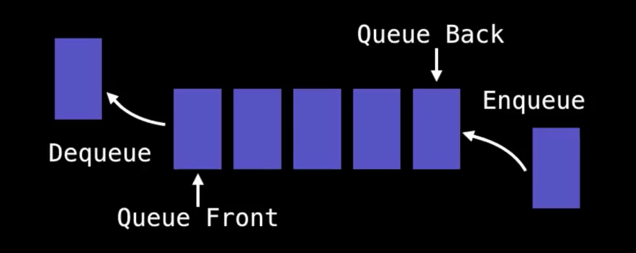

### When and where is a Queue used?

* Any waiting line models a queue, for example a line-up at a movie theatre.
* Can be used to efficiently keep track of the x most recently added elements.
* Web server request management where you want first come first serve.
* Breadth first search (BFS) graph traversal.

|  |  |  |
| --- | --- | --- |
| std::queue | | |
| Operation |  | Complexity |
| q.push(x) | Add element to the back of the queue. | O(1) |
| q.pop( ) | Remove element from the front of the queue. | O(1) |
| q.front( ) | Look at the value at the front of the queue. | O(1) |
| q.back( ) | Look at the value at the back of the queue. | O(1) |
| q.empty( ) | Check if queue is empty or not. | O(1) |
| q.size( ) | Return size | O(1) |

|  |
| --- |
| int main(int argc, char* argv[]) {  *queue*<int> dQueue; // By default, underlying container is deque.  dQueue.*push*(1); dQueue.*push*(2);  dQueue.*push*(3); dQueue.*push*(4);  while (!dQueue.*empty*()) {  *cout* << ' ' << dQueue.*front*();  dQueue.*pop*();  } // 1 2 3 4  *cout* << '\n';    *queue*<int, *list*<int>> vQueue; // Underlying container is now list.  vQueue.*push*(1); vQueue.*push*(2);  vQueue.*push*(3); vQueue.*push*(4);  while (!vQueue.*empty*()) {  *cout* << ' ' << vQueue.*front*();  vQueue.*pop*();  }  *cout* << '\n';  return 0;  } |

## std::priority_queue

### What is a Priority Queue?

* A priority queue is a container adaptor that provides constant time lookup of the **largest** (by default) element, at the expense of **logarithmic insertion and extraction**.
* The priority of the elements in the priority queue determine the order in which elements are removed from the PQ.
* Priority Queue is used in many popular algorithms. Priority Queue is the implementation of **Max** **Heap** by default.

NOTE: Priority queues only supports comparable data, meaning the data inserted into the priority queue must be able to be ordered in some way either from least to greatest or greatest to least. This is so that we are able to assign relative priorities to each element.

|  |  |  |
| --- | --- | --- |
| std::priority_queue | | |
| Operation |  | Complexity |
| Q.top() | accesses the top element | O(1) |
| Q.push() | inserts element and sorts the underlying container | O(log n) |
| Q.pop() | removes the top element | O(log n) |
| Q.empty() | checks whether the underlying container is empty | O(1) |

|  |
| --- |
| template<typename T>  void print_queue(T q) {  while (!q.*empty*()) {  *cout* << q.*top*() << ' ';  q.*pop*();  }  *cout* << '\n';  }  struct Comparator {  bool operator()(int a, int b) { return a > b; }  };  int main(int argc, char* argv[]) {  const auto data = { 1,8,5,6,3,4,0,9,7,2 };  *priority_queue*<int> q;  for (int n : data)  q.*push*(n);  print_queue(q); // 9 8 7 6 5 4 3 2 1 0  // Underlying container is vector and we have used custom comparator!.  *priority_queue*<int, *vector*<int>, Comparator> q1(data.*begin*(),data.*end*());  print_queue(q1); // 0 1 2 3 4 5 6 7 8 9  return 0;  } |

# Time Complexity Table

|  |  |  |  |  |  |  |  |  |
| --- | --- | --- | --- | --- | --- | --- | --- | --- |
|  | Insertion | | | Erase | | | Access | Find |
| Container | Front | Middle | Back | Front | Middle | Back |  |  |
| std::vector | O(n) | O(n) | **O(1)** | O(n) | O(n) | **O(1)** | **O(1)** | O(n) |
| std::deque | **O(1)** | O(n) | **O(1)** | **O(1)** | O(n) | **O(1)** | **O(1)** | O(n) |
| std::forward_list | **O(1)** | **O(1)** | **O(1)** | **O(1)** | **O(1)** | **O(1)** | N/A | O(n) |
| std::list | **O(1)** | **O(1)** | **O(1)** | **O(1)** | **O(1)** | **O(1)** | N/A | O(n) |
| std::set | O(log n) | | | O(log n) | | | N/A | O(log n) |
| std::multiset | O(log n) | | | O(log n) | | | N/A | O(log n) |
| std::map | O(log n) | | | O(log n) | | | O(log n) | O(log n) |
| std::multimap | O(log n) | | | O(log n) | | | O(log n) | O(log n) |
| std::unordered_set | **O(1)** | | | **O(1)** | | | N/A | **O(1)** |
| std::unordered_multiset | **O(1)** | | | **O(1)** | | | N/A | **O(1)** |
| std::unordered_map | **O(1)** | | | **O(1)** | | | **O(1)** | **O(1)** |
| std::unordered_multimap | **O(1)** | | | **O(1)** | | | **O(1)** | **O(1)** |